**CHAPTER 2**

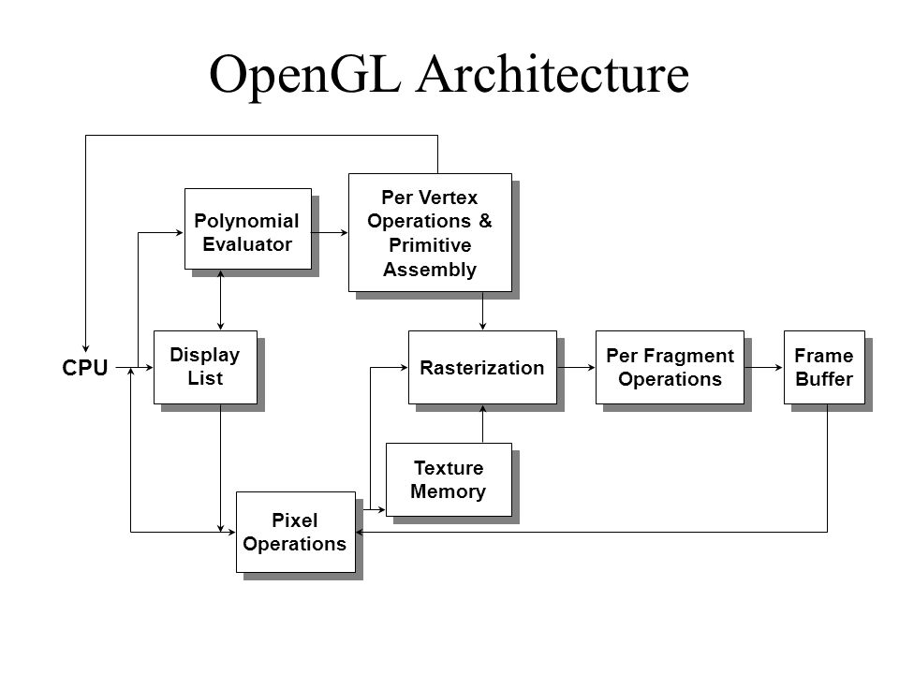 **LITERATURE SURVEY**

Fig 2.1: OpenGL Architecture System.

**2.2 About OPENGL:**

It is a Software Interface to Graphics Hardware. This interface Consists of about 150 Distinct Commands which is used to specify the objects and operations needed to produce interactive three dimensional applications. It is a Hardware-independent Interface. It has no command for windows or user input handling. It does not include low-level, device-independent, portable graphics subroutine package.

Characteristics of OPENGL are:

* Developed primarily by SGI.
* 2D/3D graphics, lower-level primitives(polygons).
* Basis for higher-level libraries/toolkits.
* Main purpose is to render two and three dimensional objects into a frame buffer. These objects are described as sequences of vertices (which define geometric objects) or pixels (which define images).
* Performs several processing steps on this data to convert it to pixels to form the final desired image in the frame buffer.